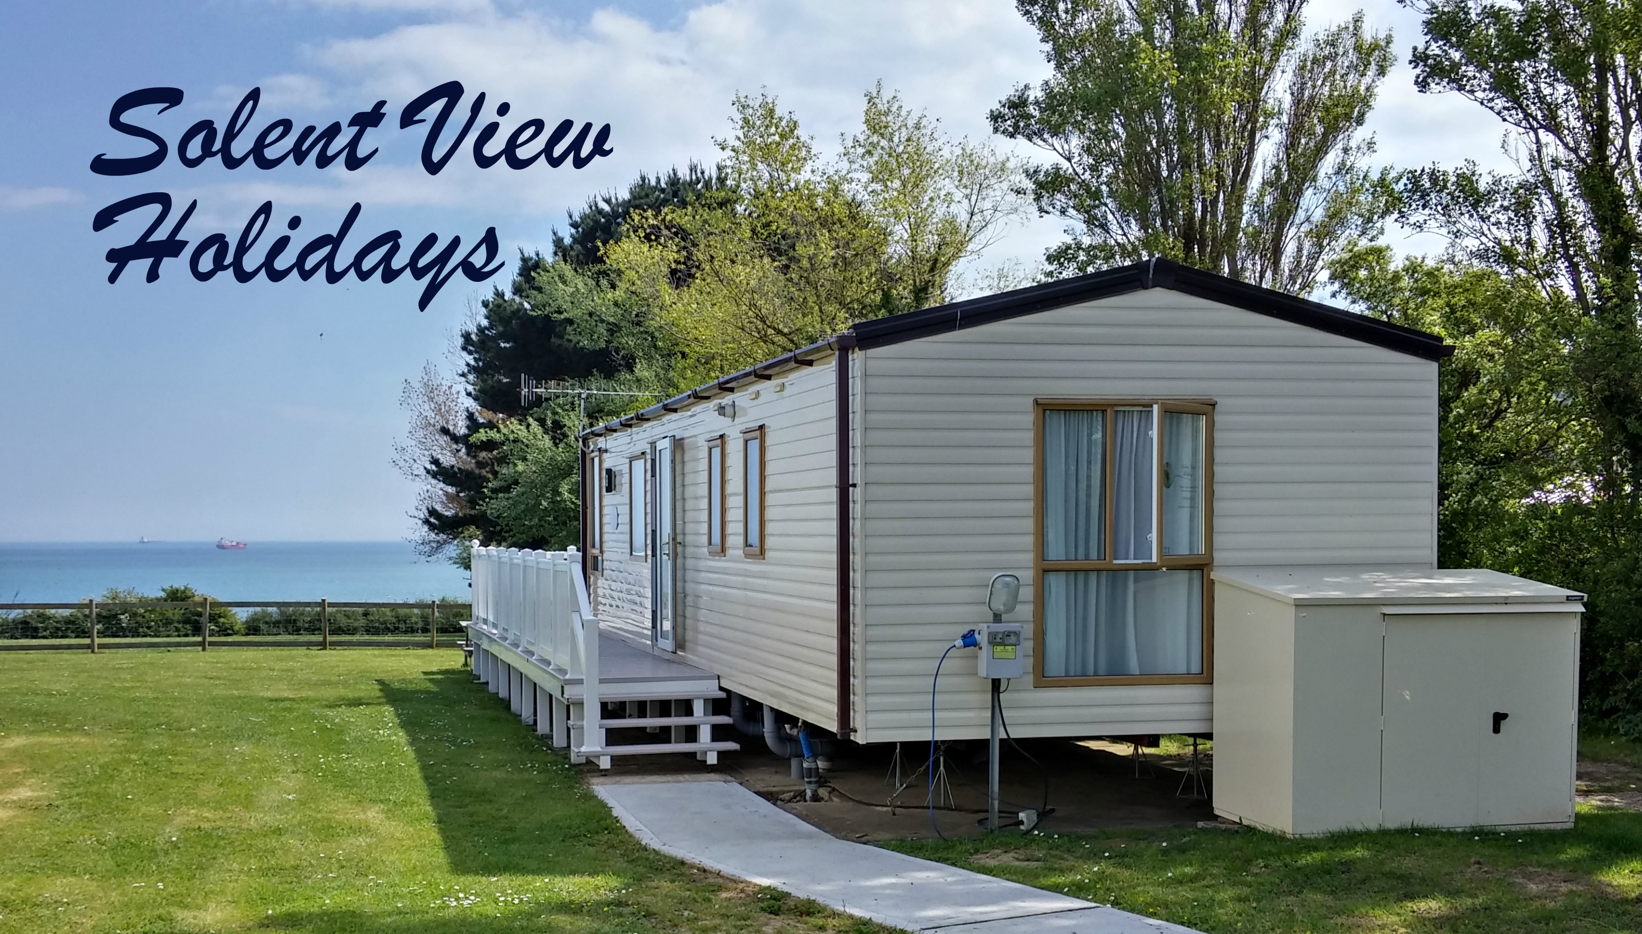
RENTAL CONTRACT
Lead Guest Name
Lead Guest Address
Arrival Date
Departure Date
Deposit Paid | £25 (CASH / CARD)*
*Delete as applicable
DISCLAIMER, TERMS & CONDITIONS

Please note that all persons using accommodation hired from us do so at their own risk. The person/s or organisation hiring the accommodation will be responsible / liable for any damage or injury occurring from or as a result of misuse or reckless use. These guidelines are for the safety of all persons using the accommodation, and is the sole responsibility of the lead guest to ensure they are fully complied with at all times. Solent View Holidays cannot except any responsibility for any injury caused to anyone using the accommodation. All individuals using the accommodation must fully comply with the terms and conditions of hire (As issued in the welcome pack). If this is not the case, individuals will be responsible for any damage to the accommodation, property of the hirer or injury. I have read the above agreement and fully understand and accept the conditions as above. I am aware that whilst in my care I am fully responsible for the accommodation and will pay for any loss or damage in full that may occur (retail price), this will include the accommodation being returned in an acceptable condition.

HIRE AGREEMENT INCLUDING TERMS AND CONDITIONS OF HIRE

This is the responsibility of the lead guest who is hiring the accommodation to ensure that all possible steps are taken to avoid injury or damage to the accommodation. Please ensure that the following Safety Instructions are followed at all times.

1  2.  3.  4.  5.  6. | The accommodation will be available from 2.30pm on the day of arrival. The lead guest should make every effort to arrive on time or give prior notice if arrival time will be significantly later than specified. The lead guest will provide adequate access and must be present at 11.00am on the day of departure to enable Solent View Holidays to check/inspect the accommodation prior to the return of a deposit.  The accommodation is for a maximum of six persons. At no time may this be exceeded. Only persons named on the booking request form are allowed to reside at the accommodation. Amendments to the original booking must be made in writing by the lead guest and are not agreed to until the lead guest receives written confirmation from Solent View Holidays.  Smoking is not permitted in the accommodation or on the decking area under any circumstances. A picnic bench is provided and this is the only area that smoking is permitted.  Pets are not permitted inside the accommodation or on the decking area at any time. It's the responsibility of the lead guest to ensure that no animals are allowed access to the accommodation by any members of the party or other persons. The accommodation is advertised as a pet free environment .  Barbecues are not allowed to be used on the decking area or within six feet of the accommodation.  Beach apparatus is not permitted within the accommodation. Sand found inside the accommodation may result in an extra cleaning charge. |  | 7.  8.  9.  10.  11.  12.  13. | To maintain the cleanliness of the accommodation, we ask that guests remove outer footwear when entering the accommodation. This is especially important after rambling or returning from the beach.  Testing and inspection of equipment, Solent View Holidays will comprehensively test all electrical equipment before commencement of hire. Equipment defects should be reported to Solent View Holidays as soon as possible. Do not attempt to repair any item supplied within the accommodation.  A security deposit of £25 (CASH/CARD) is payable on arrival. This is fully refundable as long as the terms and conditions have been met by all guests. The £25 (CASH/CARD) security deposit will be returned by Solent View Holidays on the day of departure upon a satisfactory inspection of the accommodation  Any monies outstanding on demand (interest on amounts overdue is at Santander Bank base rate plus 4%) and will be liable for legal charges incurred by Solent View Holidays in the recovery of amounts due.  Bookings cannot be extended without the prior consent of Solent View Holidays.  Ownership of equipment and goods, equipment hired remains the property of Solent View Holidays at all times.  Full terms and conditions are listed in the Guest Information book or can be found at www.solentviewholidays.co.uk

I hereby agree to abide by the terms and conditions listed above. |  |  | I acknowledge (the payer’s) £25 security deposit paid cash/card on behalf of Solent View Holidays.
Hirer Signed |  |  | On behalf of Solent View Holidays
Hirer Print |  |  | Date
www.solentviewholidays.co.uk
solentview5@live.co.uk
Solent View 5, Whitecliff Bay Holiday Park, Bembridge, Isle of Wight. PO35 5PL. MOB: 07891 829374

